# **Skempton Counter Height Dining Table and 4 Barstools Set**

**Details & Overview $607.95**

**Description**

Raise the bar on small space living with the Skempton 5-piece counter-height dining set. An inspired choice for coastal chic or modern farmhouse settings, this strikingly simple table marries a brown tone plank-effect top with a rubbed-through grayish white base for timeworn appeal. The table’s side shelves and 8-bottle wine rack cleverly balance form and function while the comfortably cushioned bar stools with classic ladderback styling serve up high style.

* Includes counter-height dining table and 4 counter-height upholstered bar stools
* Table made of solid wood, engineered wood and acacia veneers with two-tone finish
* Table seats up to 4 with 2 shelves and 8-bottle wine rack
* Stools made of solid wood with distressed grayish white finish
* Cushioned seat with polyester upholstery
* Assembly required
* Estimated Assembly Time: 150 Minutes

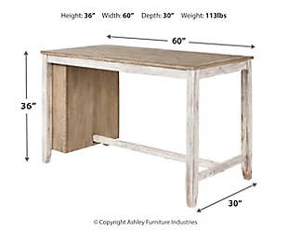**Weight**

289 lbs. (91.18 kgs.)

**Dimensions**

* Width: 60.00"
* Depth: 30.00"
* Height: 36.00"

**Additional Dimensions**

* Apron to floor: 32.63"
* Opening Width: 10.00"
* Opening Depth: 8.00"
* Opening Height: 27.75"
* Adjustable shelf (2) Width: 9.75"
* Adjustable shelf (2) Depth: 7.75"
* Adjustable shelf (2) Height: .63"
* Bottle rack Width: 12.50"
* Bottle rack Depth: 8.00"
* Bottle rack Height: 27.75"
* Seat width: 21.25"
* Seat depth: 17.50"
* Seat height: 25.00"
* Footrest height: 7.00